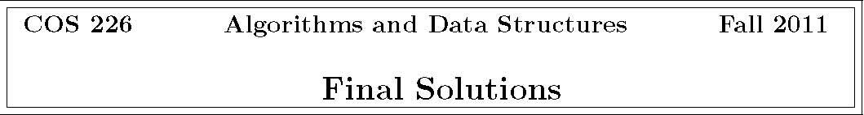
1. Analysis of algorithms.
1 N5/3
(a) T (N)= 10 .
When N increases by a factor of 8, the memory usage increases by a factor of 32. Thus,
T (N)= aNb, where b = log8 32 = lg32/ lg8 = 5/3. Since T (1000) = 10000, we have 1
10000 = a × 10005/3, which implies a =
10 .
Remark: this is essentially the same question from the midterm.
(b) BDFCBEA
i. Single loop.
ii. Similar to insertion sort.
iii. Similar to enumerating all permutations.
iv. Similar to mergesort since f1(N) takes linear time.
v. N + N/2+ N/4+ ...
vi. Similar to enumerating all subsets.
vii. Similar to binary search.
2. Graph search.
(a) 280716354
(b) 201867435

3. Minimum spanning trees.
(a) 1 2 3 4 5 8 11 15
(b) 1 5 2 4 8 3 11 15

The starting vertex must be either A or F (but it doesn’t matter which).
4. Shortest paths.
(a) 3 0 105 2
It is not necessary to run the algorithm from the beginning to deduce this because Dijkstra’s algorithm considers the vertices in increasing order of distance from the source.
(b) The next vertex to relax is 4.
v distTo[] edgeTo[]
0 | 1.0
1 | 17.0
2 | 6.0
3 | 0.0
4 | 7.0
5 | 5.0
6 | 11.0
7 | 10.0
8 | 8.0
9 | 22.0
10 | 3.0

- String sorting.
- Substring search.

c | count[] | count[] | count[]
. | . | . | .
. | . | . | .
. | . | . | .
'a' | 0 | 0 | 0
'b' | 0 | 0 | 3
'c' | 3 | 3 | 5
'd' | 2 | 5 | 11
'e' | 6 | 11 | 17
'f' | 6 | 17 | 20
'g' | 3 | 20 | 20
. | . | . | .
. | . | . | .
. | . | . | .

The answer is unique.
3 → 0 5 → 1 5 → 2
null
0 → 4 10 → 5
4 → 6 4 → 7 4 → 8 4 → 9
3 → 10
i
a[i] 0
blurb 1
climb 2
crumb 3
basic 4
cubic 5
freed
. .
. .
. .
18
dwarf 19
cliff
 | 0 | 1 | 2 | 3 | 4 | 5 | 6 | 7 | 8 | 9 | 10
A | 0 | 0 | 3 | 0 | 0 | 3 | 7 | 0 | 0 | 10 | 11
B | 1 | 2 | 2 | 4 | 5 | 6 | 2 | 8 | 9 | 6 | 4
s | B | B | A | B | B | B | A | B | B | A | A

7. Regular expressions. The NFAs for (i), (ii), (iii), and (iv) would not be constructed by our RE-to-NFA algorithm.
(i) There are two missing E-transitions: 2 → 6 and 6 → 2.
(ii) The edges 2 → 3 and 7 → 8 should be match transitions; the edge 3 → 4 should be an E-transition.

(iii) There are two missing match transitions: 2 → 3 and 4 → 5. Also, the edges 7 → 8 and 8 → 9 should be match transitions instead of E-transitions.
(iv) The E-transition 2 → 6 should instead be 0 → 5.
(v) Correct.

8. Ternary search tries.
BD C CD E FD JPG PEGS
9. String symbol table implementation.
BCDE Find the value associated with a given string A. Unordered array. key in the data structure.
CDE Associate a value with a string key. B. Ordered array.
CDE Delete a string key (and its associated value) C. Red-black BST.
from the data structure.
BCE Find the smallest string key in the data struc-D. Separate-chaining hash table.
ture.
BCE Find the smallest string key in the data struc-E. Ternary search trie.
ture that is greater than or equal to a given string.
E Find the string key in the data structure that is the longest preﬁx of a given string.
E How many string keys in the data structure starts with a given preﬁx?
Can also be done with an ordered array (B) or a red-black BST (C) by calling rank() twice, once with the preﬁx and once with the last character in the preﬁx incremented by one.
10. Data compression.
(a) CAACB
i. The frequency of A can be less than the frequency of B or it can be equal to the frequency of B.
ii. Since A and B are merged ﬁrst, they have are symbols that have the smallest frequencies.
iii. Clearly freq(D) ≥ freq(A). Suppose freq(D)= freq(A). Then, since freq(D) ≥ freq(C) ≥ freq(A), we must have freq(D)= freq(C)= freq(A). In this case, C and D would be merged (instead of C and {A, B}).
- If A, B, and C have frequency 1, then D could have frequency 2 or 3 and produce the same subtree.
- If the frequency of E is strictly less than that of A, B, and C combined, then so is the frequency of D. Hence, D and E would be merged.

Note that if a character appears 0 times, then it will not appear in the Huﬀman trie.

(b)
LZW-encoded message
4241 4E 82 41 80 42 41 83 80 41 42 8182 80 41 42 8183 80 42414E 44 41 4E 4180
original message or brief explanation why invalid
BANANA not possible since 83 would not yet be in table ABABBA ABABABA (see p. 843 of textbook) not possible because of second occurrence of 41 4E
11. Maximum ﬂow.
(a) 16+13+10 =39.
(b) s → 1 → 2 → 6 → 5 → t.
(c) After using the previous augmenting path, there are no more augmenting paths. The value of the maximum ﬂow is 41 (10 + 15 + 16).
(d) {s, 1, 2, 4}.

(e) 10+4+17+10 =41. This equals the value of the maximum ﬂow, as it should.
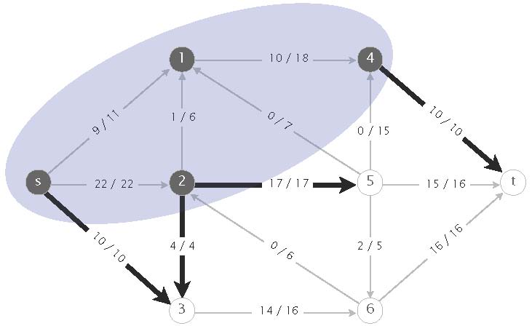
12. Algorithm design.
(a) Build an edge-weighted graph G/ containing all of the edges whose weight is strictly less than that of e = v − w. Find the connected components in G/. By the cut property, e is in the MST if and only if v and w are in diﬀerent components.
(b) E + V .

13. Reductions.
(a) For each i, set b[i] equal to a[i] and c[i] equal to -a[i].
(b) Solution 1: For each j, include the integer b[j] + M (guaranteed to be positive); for each k, include the integer -(c[k] + 2*M) (guaranteed to be negative). Any triple in a[] that sums to zero must include two positive integers and one negative integer.

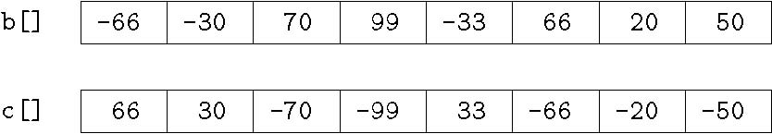
a[]
1299 | 1700 | 1010 | 1014 | 997 | 999 | 1020
-2999 | -2019 | -1996 | -2600 | -2030 | -2020

Solution 2: For each j, include the integer 10*b[j] + 1; for each k, include the integer -(10*c[k] + 2). To see why this works, consider the sum of the three integers modulo
10. Note: can replace 10 with any integer greater than or equal to 4.

